1. Write a class called ***PlayerInformation***.

This class has three public variables,

* name (string)
* surname (string)
* age (int)

Create a constructor for this class to ensure the related variables.

In the main function,

Create an object from the ***PlayerInformation*** class. Then, using the object, output the player's name, surname, and age. Consider the sample run given below.

**Sample Run:**



1. Write a class called ***Employee.***

***Employee*** class has four variables,

* firstName (string)
* lastName (string)
* employeeID (int)
* salary (double)

***The employee*** class has a constructor and a member function named *displayInfo()* to output the related employee’s information on the screen.

In the main function, create an object from the class by setting the related employee’s name, surname, id, and salary. Then, by using this object call the member function *displayInfo().*

Consider the sample run given below.

**Sample Run:**

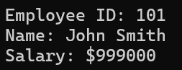

1. Write a class called ***Book.***

***Book*** class has,

* a variable named title (string)
* a constructor should print the message “Book created: (Book Title)”
* a destructor prints the message “Book destroyed: (Book Title)” when the object is destroyed.
* a member function named *display()* that prints the book title on the screen.

In the main,

Create an object from this class with the title “The Little Prince,” allocate memory for it, and store the address of this object in the pointer object. This allows you to access objects through the pointer. Then, call the *display()* function to print the book information. At the end of the program, delete everything to deallocate the memory for the book.

**Sample Run:**

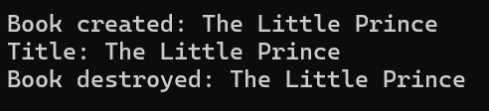

1. Write a constructor and destructor for the class ***Country*** considering the main function given below and according to the following output as seen below. (Use overloaded constructors to ensure the result.)

int main()

{

Country Object1("Turkey");

Country Object2("Germany",79);

Country Object3("Brazil",17,214000000);

return 0;

}

**Sample Run:**



1. Write a C++ program for a class Square to hold information of the square.

It has an integer value for a side as private data member. Print in constructors and destructor; “default constructor”, “overloaded constructor” or “destructor” appropriately. Write two member functions for calculating area and perimeter.

**Sample Run:**

